GOLO API Sample Response in Postman

1) - Monitoring Server

- Start: [http://[host]:[port]/api/monitor/start?hostname=[server]&interval=[time](http://[host]:[port]/api/monitor/start?hostname=%5bserver%5d&interval=%5btime)]

-Example: <http://localhost:8090/api/monitor/start?hostname=https://api.test.paysafe.com/accountmanagement/monitor&interval=500>

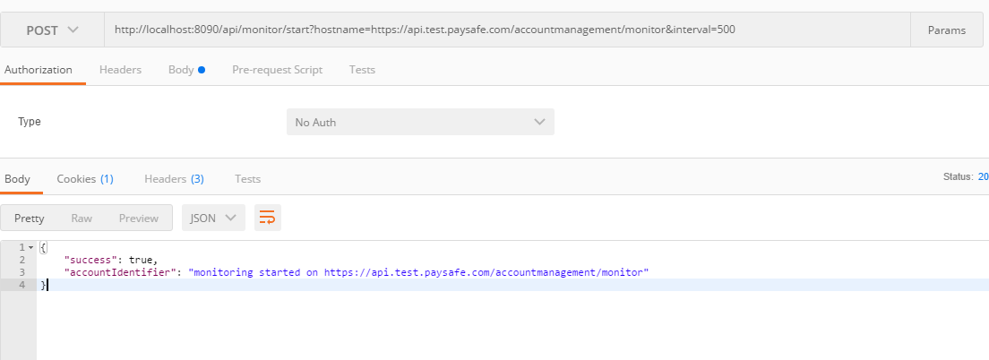

2) - Monitoring Server

- Stop:

[http://[host]:[port]/api/monitor/stop?hostname=[server](http://[host]:[port]/api/monitor/stop?hostname=%5bserver)]

-Example: <http://localhost:8090/api/monitor/stop?hostname=https://api.test.paysafe.com/accountmanagement/monitor>

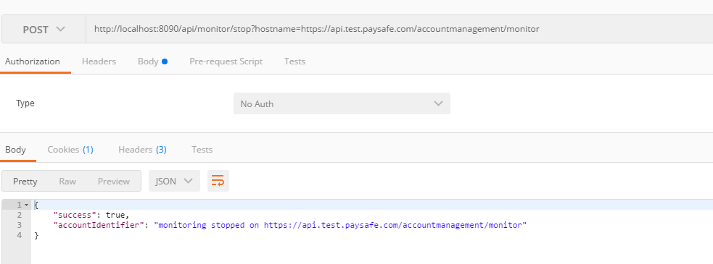

- Get Server Statistics

- Overview:

[http://[host]:[port]/api/monitor/overview?hostname=[server](http://[host]:[port]/api/monitor/overview?hostname=%5bserver)]

-Example:

<http://localhost:8090/api/monitor/overview?hostname=https://api.test.paysafe.com/accountmanagement/monitor>

